# Abdalla Haitham

# NW

# Evening Study

# Web Programing LAB

# Discussion 7

**1-***What are the generic font families? Explain in details with examples*

**SOL/**

1. Serif Font Families: Serif fonts have small lines attached to the characters, giving them a more elegant look. Times New Roman and Georgia are examples of serif fonts.
2. Sans-serif Font Families: Sans-serif fonts are characterized by having no lines attached to the characters. Arial and Verdana are examples of sans-serif fonts.
3. Monospace Font Families: Monospace fonts have equalwidth characters. They are commonly used in programming code and are space-efficient. Courier New and Monaco are examples of monospace fonts.
4. Script Font Families: Script fonts have a handwritten appearance and are typically used for titles or decorative purposes. Zapfino and Brush Script are examples of script fonts.
5. Fixed-width Font Families: These fonts have fixed widths for every character. They are commonly used in code, where consistent spacing is important. Consolas and Monaco are examples of fixed-width fonts.

**2-It is recommended to use each family of generic fonts in fallback style. Why?**

**SOL/**

1. To provide consistency across different operating systems and browsers, you should use each family of generic fonts in a fallback style.
2. By specifying fallback fonts, you can ensure that the browser selects an appropriate font from the user's system, in case the preferred font is not available.
3. Each generic font family corresponds to a different style or group of fonts. They are used to select fonts that share a certain visual characteristic. For example, using "sans-serif" selects fonts with no serifs, while "monospace" selects fonts with a fixed width.
4. Fallback fonts also ensure that the browser selects an appropriate font from the user's system in case the preferred font is not available.
5. Finally, by using fallback fonts, you can maintain consistency and avoid the potential of design breakage when a specific font is not available on a user's system.

In summary, using fallback fonts is important to provide a consistent design across different platforms and browsers.

**3-How can you insert Hoverable Table by CSS? Show me by code.**

**SOL/**

<!DOCTYPE html>

<html>

<head>

<style>

table {

border-collapse: collapse;

width: 100%;

}

th, td {

border: 1px solid #dddddd;

text-align: left;

padding: 8px;

}

tr:hover {

background-color: #f5f5f5;

}

</style>

</head>

<body>

<table>

<tr>

<th>Header 1</th>

<th>Header 2</th>

<th>Header 3</th>

</tr>

<tr>

<td>Data 1</td>

<td>Data 2</td>

<td>Data 3</td>

</tr>

<tr>

<td>Data 4</td>

<td>Data 5</td>

<td>Data 6</td>

</tr>

<!-- Add more rows as needed -->

</table>

</body>

</html>

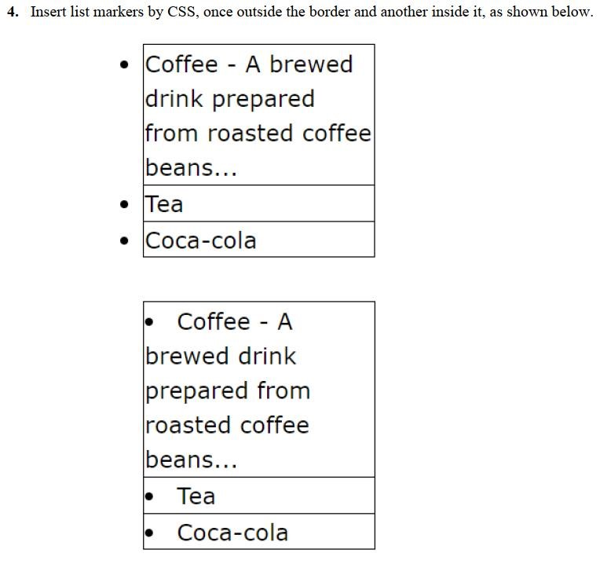

**SOL/**

<!DOCTYPE html>

<html>

<head>

<style> .container { width: 15%; padding: 10px; margin: 10px;

}

.item {

|  |
| --- |
| padding: 5px 10px; position: relative; border: 1px solid black;  } .item2 { padding: 5px 10px; position: relative; border: 1px solid black;  } .item3 { padding: 5px 10px; position: relative; border: 1px solid black;  } .item0 { padding: 5px 10px; position: relative; border: 1px solid black;  }  .item:before { content: "• "; color: rgb(255, 0, 0); position: absolute; left: -20px;  }  .item2:before { content: "• "; color: rgb(47, 0, 255); position: absolute; left: -20px;  }  .item3:before { content: "• "; color: rgb(9, 255, 0); position: absolute; left: -20px;  }    </style>  </head>  <body>  <div class="container">  <ul>  <div class="item">•Coffee A brewed - drink prepared from roasted coffee beans ...</div> |

<div class="item2">•Tea</div>

<div class="item3">• Coca-cola</div>

</ul>

</div>

<div class="container">

<ul>

<div class="item0">•Coffee A brewed - drink prepared from roasted coffee beans ...</div>

<div class="item0">•Tea</div>

<div class="item0">• Coca-cola</div>

</ul>

</div>

</body>

</html>

